**CSS UNITS**

1. **Absolute Units**

Absolute units are those that are always the same in any context. ‘px’ (the only absolute unit you should be use) is an absolute unit because the size of a pixel doesn’t change relative to anything else on the page.

1. **Relative Units**

Relative units are units that can change based on their context.

1. rem and em

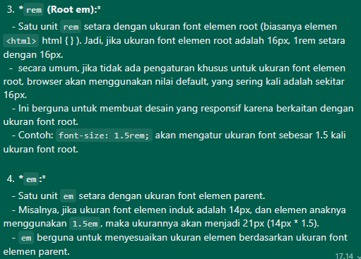

1. Viewport

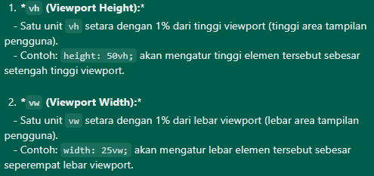

1. 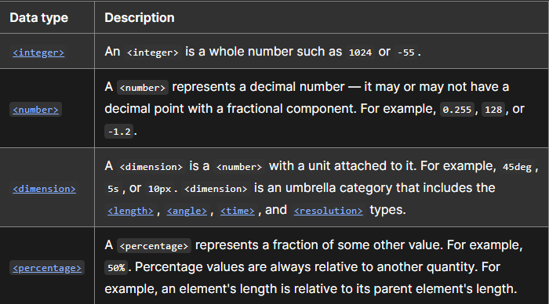**Additional**
2. Suggestion
3. 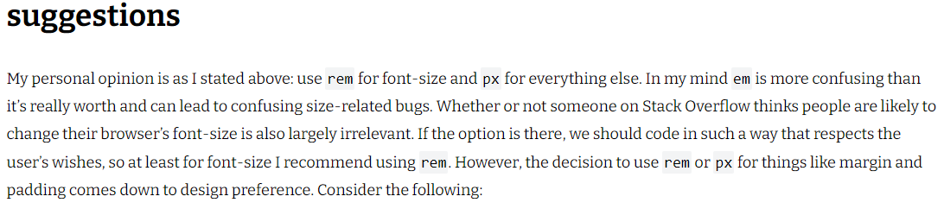<https://codyloyd.com/2021/css-units/>
4. <https://css-tricks.com/fun-viewport-units/>

Some example like Responsive Typography, Scroll Indiactor, etc.